# Setup for Microsoft Azure Storage Account for use with Aparavi Agent/Collector

# Purpose

Microsoft Storage Account and its file share services can be connected via Server Message Block (SMB) protocol using the Aparavi Agent/Collector and configured to search for unstructured data. The benefit of this method is the great flexibility in designing an individual infrastructure architecture, which can also bring cost advantages.

The following description of the setup assumes that an Aparavi Agent or Collector is already installed on a supported operating system and connected and online in the Aparavi Presentation Layer.

Following link leads to a detailed installation guide of the entire Aparavi Platform:

[www.aparavi.com/support](http://www.aparavi.com/support)

After successfully setting up the Microsoft Azure storage account, only the path and credentials for the storage account need to be specified. The data is then scanned either automatically or manually from the Aparavi Presentation Layer, as required.

# Use/Architecture

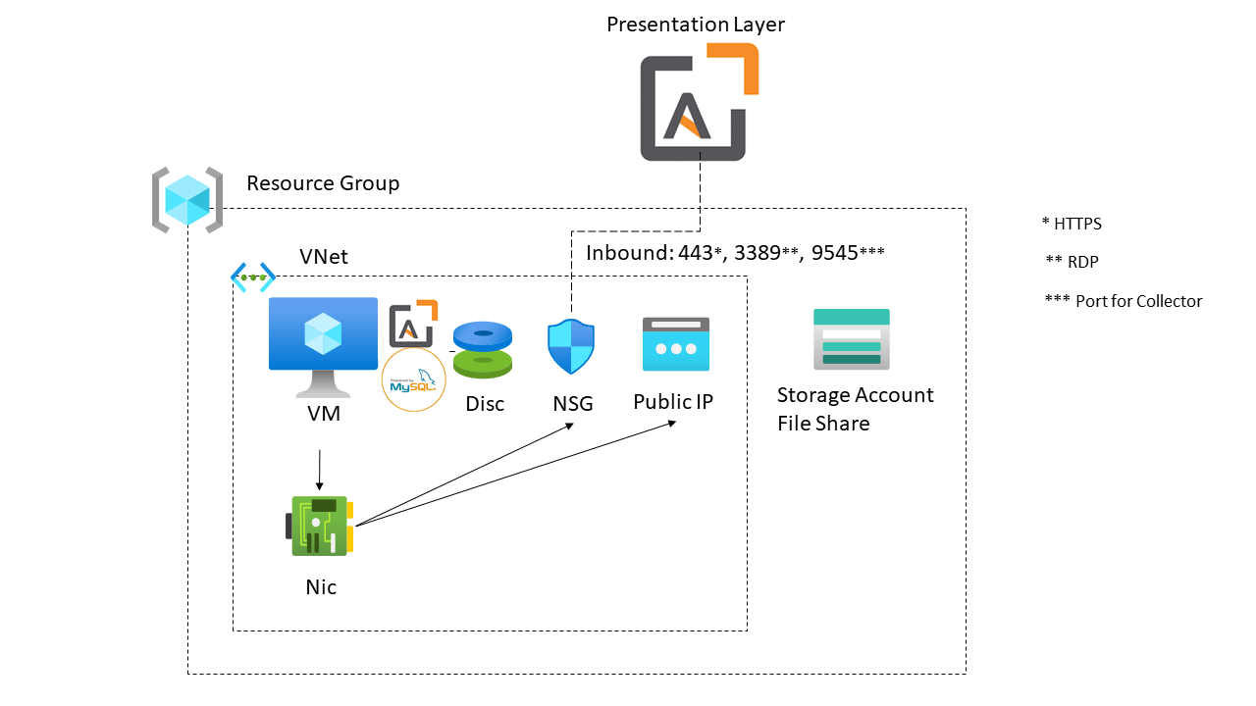

# Setup

This article assumes that you have already created an Azure subscription. If you don't already have a subscription, then create a [free account](https://azure.microsoft.com/de-de/free/?WT.mc_id=A261C142F) before you begin.

Following link leads to a detailed installation guide of the entire Aparavi Platform:

[www.aparavi.com/support](http://www.aparavi.com/support)

We provide this description for better understanding of the architecture.

However, you can use a fully automated setup based on ARM Template which can find here:

[aparaviemea/Installation: Installation files (github.com)](https://github.com/aparaviemea/Installation)

# Create a storage account and file share

* 1. On the Azure portal menu, select All services. In the list of resources, type Storage Accounts. As you begin typing, the list filters based on your input. Select Storage Accounts.
  2. On the Storage Accounts window that appears, choose + New.
  3. On the Basics blade, select the subscription in which to create the storage account.
  4. Under the Resource group field, select your desired resource group, or create a new resource group. For more information on Azure resource groups, see Azure Resource Manager overview.
  5. Next, enter a name for your storage account. The name you choose must be unique across Azure. The name also must be between 3 and 24 characters in length and may include only numbers and lowercase letters.
  6. Select a region for your storage account or use the default region.
  7. Select a performance tier. The default tier is Standard.
  8. Specify how the storage account will be replicated. The default redundancy option is Geo-redundant storage (GRS). For more information about available replication options, see Azure Storage redundancy.
  9. Additional options are available on the Advanced, Networking, Data protection, and Tags blades. To use Azure Data Lake Storage, choose the Advanced blade, and then set Hierarchical namespace to Enabled. For more information, see Azure Data Lake Storage Gen2 Introduction.
  10. Select Review + Create to review your storage account settings and create the account.
  11. Select Create. Ein Bild, das Text enthält.

      Automatisch generierte Beschreibung
  12. When the Azure storage account deployment is complete, select Go to resource.
  13. Select File shares from the storage account pane. 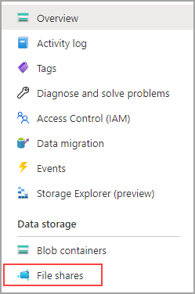
  14. Select File shares.
  15. Select + file share to create a new file share.

More information: [Create an Azure file share - Azure Files | Microsoft Docs](https://docs.microsoft.com/en-us/azure/storage/files/storage-how-to-create-file-share?tabs=azure-portal)

# Configuration Of Aparavi Agent / Collector

[THIS CONFIGURATION IS NOT AUTOMATED BY THE ARM TEMPLATE]

This article assumes that you have already successfully installed an Aparavi Aggregator and a Collector, or an Agent and that the corresponding client is online.

# Definition of the crendentials in Aparavi Presentation Layer for the use with Microsoft Azure Storage Account

1. Log in to the Aparavi Presentation Layer
2. Check the status of the Agent / Collector and make sure that it is onlineEin Bild, das Text enthält.

   Automatisch generierte Beschreibung
3. Chose your client and select “Policies”. Then, chose “Include Path”.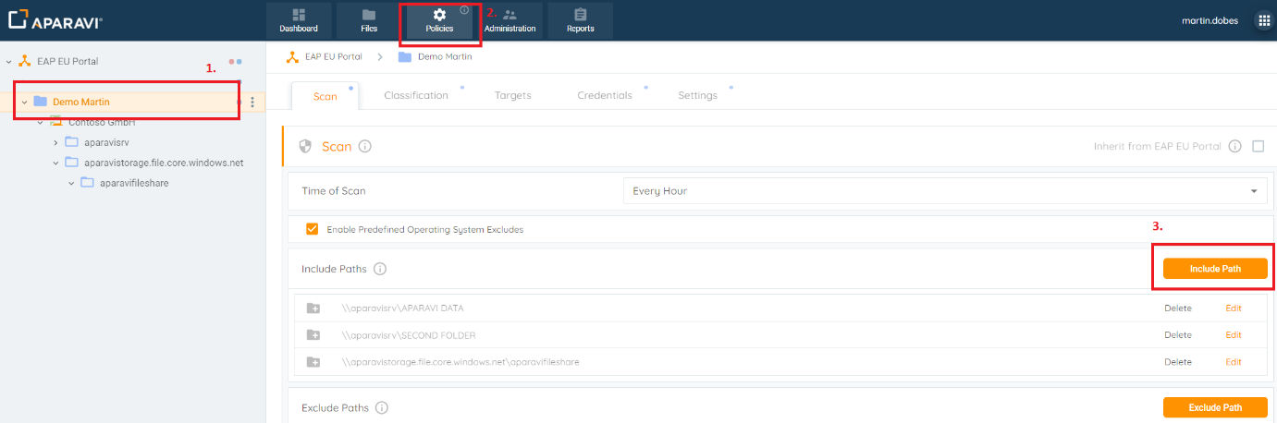
4. The correct path definitions follow this rule: \\<NAME OF THE STORAGE ACCOUNT>.file.core.windows.net\<NAME OF THE FILE SHARE>, example: \\aparavistorage.file.core.windows.net\aparavifileshare
5. After this step, set the correct credentials for the storage account.
6. Switch to “Credentials” and click the button “Add Credentials”.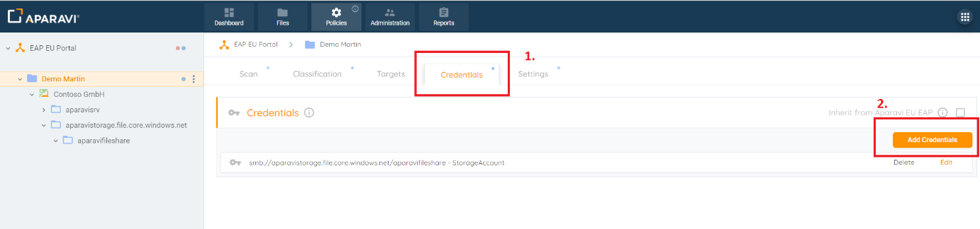
7. The “User” corresponds to the name of the Azure Storage Account. The “Password” requires the “Key” of the Azure Storage Account which can be find in the Azure Portal.

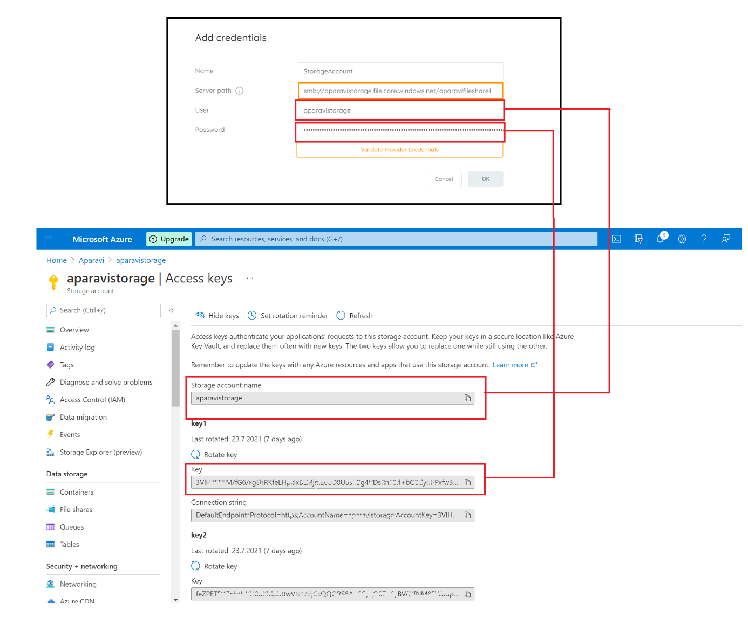

Now, it is possible to migrate your test data to the Azure Storage Account and connect the data with the Aparavi Platform.

You can use the Microsoft Storage Account Explorer for data migration. [Azure Storage Explorer – cloud storage management | Microsoft Azure](https://azure.microsoft.com/en-us/features/storage-explorer/#overview)